Circular Queue
In a normal Queue Data Structure, we can insert elements until queue becomes full. But once if queue becomes full, we can not insert the next element until all the elements are deleted from the queue. For example consider the queue below...
After inserting all the elements into the queue.

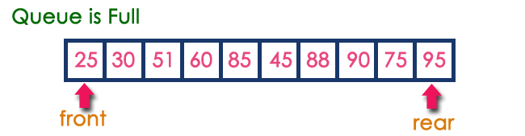

Now consider the following situation after deleting three elements from the queue...
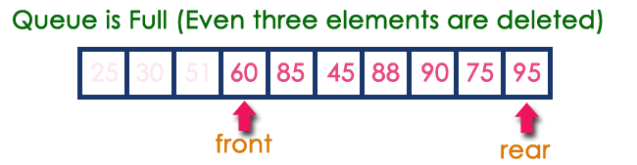
This situation also says that Queue is Full and we can not insert the new element because, 'rear' is still at last position. In above situation, even though we have empty positions in the queue we can not make use of them to insert new element. This is the major problem in normal queue data structure. To overcome this problem we use circular queue data structure.
CIRCULAR QUEUE :
In a standard queue data structure re-buffering problem occurs for each dequeue operation. To solve this problem by joining the front and rear ends of a queue to make the queue as a circular queue
Circular queue is a linear data structure. It follows FIFO principle.
- In circular queue the last node is connected back to the first node to make a circle.
- Elements are added at the rear end and the elements are deleted at front end of the queue
- Both the front and the rear pointers points to the beginning of the array.
- It is also called as “Ring buffer”.

Circular Queue can be created in three ways they are
- Array
- Dynamic Array
- Linked List

Circular Queue Program:
#include<stdio.h>
void insert();
void delet();
void display();
int cqueue[5], rear=-1, front=-1, item;
void main()
{
clrscr();
insert();
insert();
insert();
insert();
insert();
display();
delet();
display();
insert();
display();
insert();
getch();
}

void insert()
{
if((front==0 && rear==4) || (front==rear+1))
printf("\n Circular Queue is full.");
else
{
printf("\nEnter ITEM: ");
scanf("%d", &item);

if(rear == -1)
{
rear = 0;
front = 0;
}
else if(rear == 4)
rear = 0;
else
rear++;

cqueue[rear] = item;
printf("\nItem Inserted: %d\n", item);
}
}
void delet()
{
if(front ==-1)
printf("\n\n Circular Queue is empty.\n");
else
{
item = cqueue[front];

if(front == rear) // rear may not be last index
{
front = -1;
rear = -1;
}
else if(front == 4)
front = 0;
else
front++;
printf("\n\nITEM deleted: %d", item);
}
}

void display()
{
int i;
if(front==-1)
printf("Queue is Empty, No Elements to Display");
else if(front<=rear)
{
printf("\nCircular Queue Elements are :\n");
for(i=front; i<=rear; i++)
printf("Element %d\n",cqueue[i]);
}
else
{
printf("\nCircular Queue Elements are :\n") ;
for(i=front; i<=4; i++)
printf("Element %d\n",cqueue[i]);
for(i=0; i<=rear; i++)
printf("Element %d\n",cqueue[i]);
}
}

